Home learning - Should you choose to

Maths – For all year groups. Reception, Year One and Year Two
A great resource is now provided - This is the math’s framework we use in school.
They have created clips to teach you and the children before completing tasks.
There is 1 video and 1 task for each day.
This is following our current math’s plans.
https://whiterosemaths.com/homelearning/
Phonics
Phonics play is now free for all - This is particularly useful for Reception and Year 1
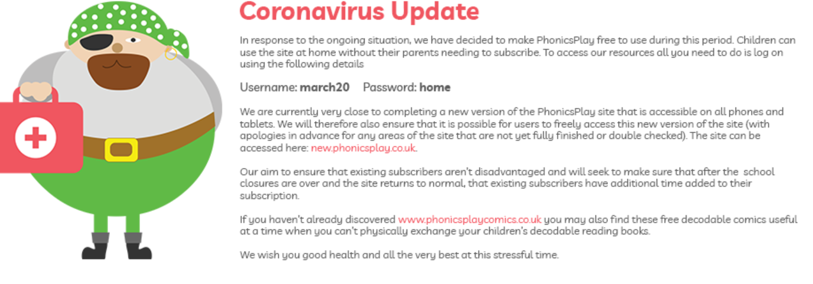

Please know that there is no expectation currently for home learning to be taking place, this is optional - the children will learn during all activities.
The current computer systems are adjusting to the demands so please be patient.
Whilst the sun is shining enjoy your gardens if possible.
Children may send emails to their class email address to share things they have done.
Teachers may respond via Marvelous me on a Friday if they are able to.
badger@stjohns-farnham.surrey.sch.uk
fox@stjohns-farnham.surrey.sch.uk
rabbit@stjohns-farnham.surrey.sch.uk

